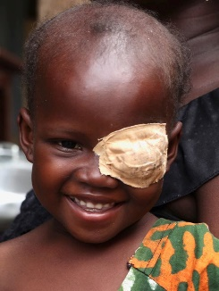
Programme Funding Manager
Recruitment Pack
Closes: Tuesday 25^{h} May 2021
Interviews: Tuesday 8th or Wednesday 9th June 2021

Dear Applicant

Thank you for your interest in joining World Child Cancer.

We are a passionate and results driven team with a genuine desire to innovate, collaborate and fundraise to support children with cancer and their families across the world. We have an ambitious target to reach 16,000 children per year by 2025 and a key way for us to achieve that is through increasing donations from trusts, foundations and statutory sources.

We currently raise just over £2m each year and have ambitions to grow to £5m by 2025 and raising income from charitable trusts, foundations and statutory funders is one of the key drivers of this growth.

At World Child Cancer, we deliver amazing programmatic work and have a strong case for support with inspiring stories to tell, like that of Sahara. We need you to help increase income from trusts and statutory sources.

If you are excited by this opportunity and have the ambition and drive to help us achieve our goals, I would love to hear from you. Please email to arrange a time to discuss the role or send your application to: domitille.delagorce@worldchildcancer.org

Yours sincerely

Domitille de La Gorce
Head of Trust and Statutory Funding

About World Child Cancer
Over 400,000 children worldwide develop cancer each year. Childhood cancer is often curable, with an 84% survival rate in high-income countries. However, in many low-income countries survival rates are 10% or lower with many children never even receiving a diagnosis, instead they die of a mystery illness without even palliative care.

The main reasons for this discrepancy are children not being diagnosed and referred, the lack of high-quality treatment (there are often just one or two hospitals in a country capable of treating childhood cancer) and families either rejecting starting treatment or abandoning it for economic or cultural reasons part way through.

As child mortality reduces across the world the proportion of childhood deaths due to cancer are increasing. In middle-income countries such as Brazil it is now the second biggest cause of death after accidents for 5-14 year olds.

In response, in 2018, the World Health Organisation (WHO) announced the WHO Global Initiative for Childhood Cancer which aims to double the current global cure rate to 60% by 2030, saving an additional one million lives. World Child Cancer has been invited to join various WHO working groups to implement the programme.

Our vision is a world where every child with cancer has equal access to the best treatment and care.

World Child Cancer improves the diagnosis, treatment and support of children with cancer in low and middle-income countries and provides support to their families.
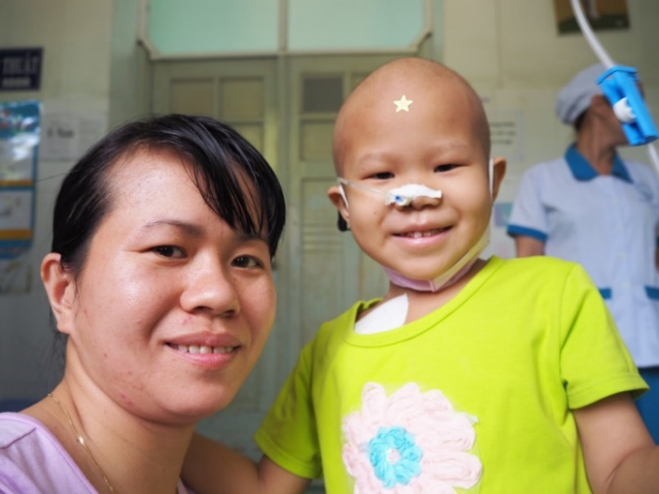
We achieve this by twinning the hospitals we support in low and middle-income countries with leading childhood cancer units in high-income countries.
These partnerships, together with staff training and mentoring, provide valuable transfer of expertise which builds the sustainable capacity and knowledge of doctors and nurses in-country. We also develop holistic care for families, support treatment costs, provide ward equipment and fund essential staff posts. To affect long term change, we also deliver awareness-raising programmes and liaise with policy-makers at home and abroad.

We currently work in twelve countries across Africa, Asia and Central America. Since we started working in Ghana in 2010, we have more than tripled the number of children diagnosed through our programme and more than tripled survival rates, which means that ten times as many Ghanaian children now survive cancer each year. In 2019 we launched an exciting new partnership with UBS Optimus Foundation to develop a centre of excellence in Ghana to train the next generation of paediatric oncologists for west Africa and beyond.
Job Description
Job Title: Programme Funding Manager
Reports to: Head of Trust and Statutory Funding

Overview
The post holder will play a key role in raising income from Charitable Trusts, Foundations and Statutory sources to fund World Child Cancer’s programmatic work. Working closely with the Head of Trusts and Statutory Funding and Programmes Team you will research, identify and steward potential trusts and statutory funders and develop comprehensive funding proposals. You will also take a lead role in the grant management of several FCDO grants.
The post holder will be passionate about World Child Cancer’s cause and focussed on raising funds to enable the continuation and growth of its programmes.
This role will have a direct impact on the number of children with cancer we are able to support in the future. We need someone with ambition, drive and passion who is hungry to grow income further.
Key elements of the role
- To contribute to reaching or exceeding the annual trust and statutory income target of £1.7m
- To effectively and appropriately contribute to cultivating prospective and existing trusts, foundations and statutory funders
- To work with the Charity’s Trustees and other key supporters to identify leads and connections.
- To undertake research into trusts, foundations and statutory funders and execute a calendar of approaches.
- To work with the charity’s Programmes Team to identify projects and package these accordingly with robust proposals and budgets.
- To support World Child Cancer US in identifying and producing robust proposals where we can add value to our programmatic work.
- To manage reporting to donors, in particular take the lead on the grant management of several FCDO grants.
- To ensure all relevant staff are comprehensively briefed in a timely manner ahead of meeting any prospective or existing funders.
- To maximise return from our networking events.
- To represent the Charity with donors and at events.
- To ensure all donor communications are logged on the CRM database (Raisers Edge)
- To deliver exceptional supporter care.
- To ensure the Charity complies with Fundraising best practice and any relevant legislation at all times.
Person Specification
 | Application, Test, Interview
Essential
Ability to research and identify potential new donors | A, I
A proven track of fundraising significant sums from trusts, foundations and statutory funders | A, I
Exceptional communication skills, able to build relationships with people at all levels of seniority | A, I
The ability to translate complex, specialist information into accessible and compelling proposals and reports for a variety of strategic and other grant funders | A, T, I
Experience of working on multiple projects at the same time and cross-departmentally | A, I
A positive team player | A, I
The ability to work on own initiative, prioritising workload with little supervision when needed | A, I
Empathy and diplomacy surrounding the issues of children’s health and the passion to want to improve the lives of children with cancer | A, I
Experience of working in the international development sector | A, I
Understanding of project management
A willingness to travel within the UK and abroad when required including weekends and evenings | A, I
Strong IT skills using the Microsoft Office package | A, I
Desirable
A proven track record of setting and managing budgets | A, I
Experience of using networking events to prospect and steward funders | A
Experience of applying to / managing grants from the FCDO (DfID) | A
Educated to degree level or equivalent | A
Experience of managing staff and/or volunteers | A, I
Fundraising qualification | A
Experience with Raisers Edge or other CRM databases | A, I

Terms of Employment
Hours: 35 hours per week
Location: 9 Maltings Place, 169 Tower Bridge Road, London SE1 3JB. Currently working from the office two days per week.
Contract: Permanent (after 6 months’ probation)
Salary: circa £32,000 - £35,000 FTE (depending on experience)
Annual Leave: 25 days, 8 bank holidays and an additional day at Christmas
Pension: 10% employer contribution after 3 months (employee contributions optional)
Other: Opportunity to participate in the cycle to work scheme

How to apply
To apply for this position, please provide your CV including details of two referees and a supporting statement (maximum 2 pages) that addresses the “essential” criteria in the Person Specification.

As strong written communication skills are one of the criteria, we will be looking for evidence of this in your supporting statement and layout of your CV.

Applications should be emailed to: Domitille.delagorce@worldchildcancer.org with “Programme Funding Manager” in the subject line. The successful appointment is subject to a satisfactory criminal records disclosure and written references.

Timetable
Closing date for applications: Tuesday 25th May 2021
First interview: Tuesday 8th June or Wednesday 9th June 2021
Second interview: tbc

If you have any queries or wish to have an informal discussion, please contact Domitille de La Gorce at Domitille.delagorce@worldchildcancer.org

